Category 6 Unshielded Keystone Jack

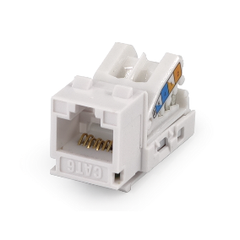

Category 6 unshielded keystone jack is designed for superior performance and easy assembly, meets and exceeds ANSI/TIA-568.2-D and ISO/IEC 11801 2nd edition Category 6 standards, supporting Gigabit Ethernet application and beyond. Narrow width design fits 24 ports in one unit panel for most efficient use of 1U panel. Jacks are available in 9 colors to match housing or allow color-coded designation port in compliance with TIA-606 requirements.

Features

Contacts are phosphor bronze plated with 50 micro inches hard gold

Option for KRONE/110 Universal IDC connector or tool-free type

Supplied with plastic strain relief cap for IDC connectors

Large selection of colors, provides many options of color coded designation port

Polycarbonate 94V0 rated

Itertek ETL / Force EC Cat.6A VERIFIED

4PPoE compliant in accordance with IEEE802.bt Type 4

Ordering Information

|  |  |
| --- | --- |
| PART | Description |
| 1A68TP000-XX | RJ45, 8-Conductor Cat.6, Tool-free, Unshielded, 180 degree, H.D. version |
| 0A68RP000-XX | RJ45, 8-Conductor Cat.6, KRONE/110 IDC, Unshielded, 180 degree, H.D. version, fits 0.5U panel |
| 1C68TP001-XX | RJ45, 8-Conductor Cat.6, Tool-free, Unshielded, 180 degree, H.D. version, fits 0.5U panel, no cable tie required |
| 6A68TP000-XX | RJ45, 8-Conductor Cat.6, Tool-free, Unshielded, 180 degree, H.D. version |
| 7B68TP000-XX | RJ45, 8-Conductor Cat.6, Tool-free, Unshielded, 180 degree, H.D. version, fits 0.5U panel |
| 1K68KP000-XX | RJ45, 8-Conductor Cat.6, KRONE/110 IDC, Unshielded, 90 degree, H.D. version |
| 2K68TP000-XX | RJ45, 8-Conductor Cat.6, KRONE/110 IDC, Unshielded, 90 degree, Short depth design, L=28.8mm |
| 0T68TP000-XX | RJ45, 8-Conductor Cat.6, Tool-free, Unshielded, 90 degree, H.D. version, fits 0.5U panel |
| 1T68TP000-XX | RJ45, 8-Conductor Cat.6, Tool-free, Unshielded, 90 degree, H.D. version, fits 0.5U panel |

“XX” = color choices – ivory (IV), white (WH), gray (GY), black (BK), red (RD), orange (OR), blue (BL), green (GN), yellow (YL)